**Scrum Meeting Report**

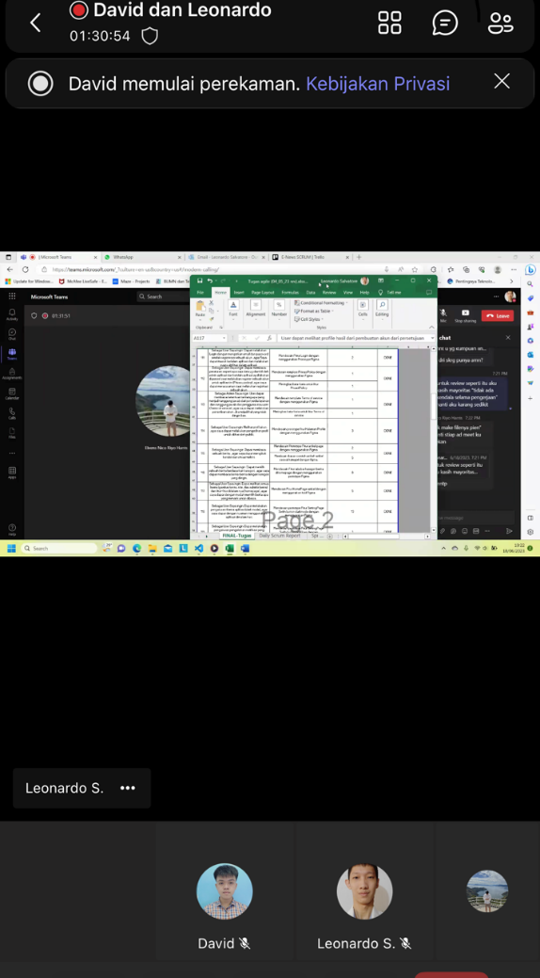**● 18 Juni 2023 , 17:25 – End**

**Link Meeting :** <https://mikroskilacid-my.sharepoint.com/:v:/g/personal/211110419_students_mikroskil_ac_id/EfJl7Qku849ForsNqT4lyDkB-zDzfqhM4jPAH8y9Y46MBQ>

**● 21 Juni 2023 , 22:26 – End** 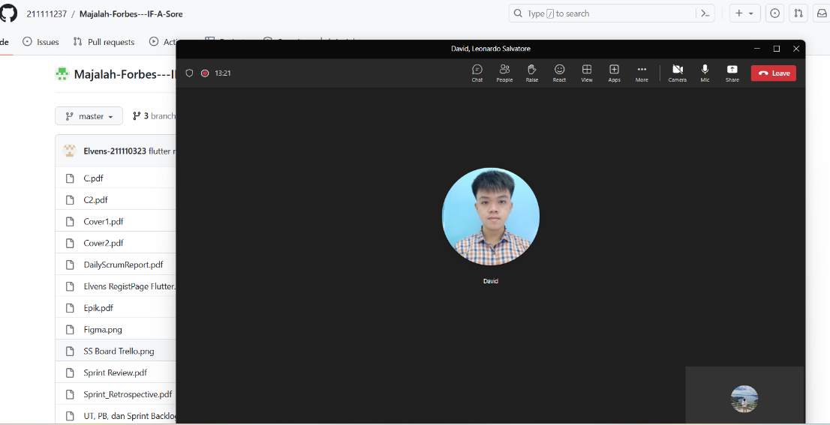

Link meeting :

<https://mikroskilacid-my.sharepoint.com/:v:/g/personal/211110419_students_mikroskil_ac_id/EW1xs6G05PdOnKItpcp3mVoBCiO9BCWNRw2SPfYRHEkbdg>

**● 25 Juni 2023 , 19:26 – End**

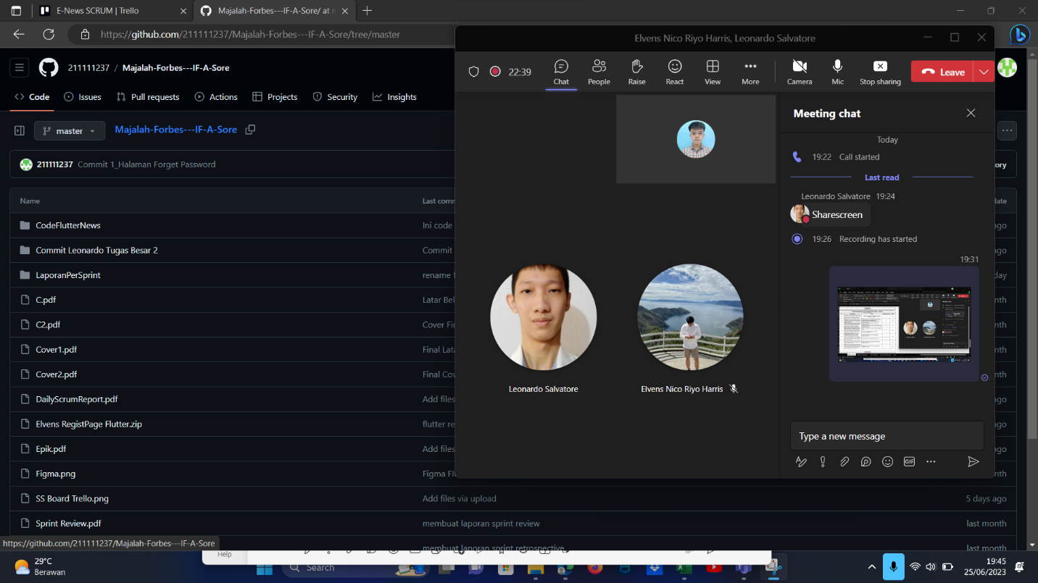

Link meeting :

https://mikroskilacid-my.sharepoint.com/:v:/g/personal/211110419_students_mikroskil_ac_id/ERq2IJL1vSdOl2Aym2lZFRkBubSrt3yAjhwmuuTzNIs4LQ